IBL dataset types

Title | Version | Last consented (Due for review)
IBL dataset types | v0.0.0 | Never
Authors
Olivier Winter, Gaelle Chapuis, Niccolò Bonacchi, Miles Wells
Editors |  | Working Group
 |  | Data Architecture Working Group
Abstract
Explanation of some of the variables listed in PyBpod DatasetTypes

Table of contents

Introduction to the IBL dataset 7
Introduction to ALF 7
Folder tree structure 7
How to get probe type 8
From spikeglx meta data file 8
From folder structure 8
How to load spike sorting data 9
Coordinate System Within Allen CCF 9
Computing response type using choice and stimulus side 11
Example 12
Aligning events to the onset of specific feedback type 12
Example 13
Spikes 14
spikes.amps 14
spikes.clusters 14
spikes.depths 15
spikes.samples 15
spikes.times 15
spikes.templates 16
Clusters 17
clusters.amps 17
clusters.depths 17
clusters.channels 18
clusters.metrics 18
clusters.probes 19
clusters.peakToTrough 19
clusters.uuids 19
clusters.waveforms 20
clusters.waveformsChannels 20
Drift Registration 21
drift.um 21
drift.times 21
drift_depths.um 22
Probes 22
probes.description 22
Channels 23
channels.localCoordinates 23
channels.probes 24
channels.rawInd 24
channels.mlapdv 24
channels.brainLocationIds_ccf_2017 25
Templates 26
template.amps 26
templates.waveforms 26
templates.waveformsChannels 27
Sample waveforms 27
_phy_spikes_subset.waveforms 27
_phy_spikes_subset.channels 28
_phy_spikes_subset.spikes 28
Raw Synchronization Data 29
_ibl_experiment.description 29
_*_DAQdata.raw 29
_*_DAQdata.timestamps 30
_*_DAQdata.meta 30
_*_DAQdata.wiring 31
Raw Electrophysiology Data 31
_iblqc_ephysSpectralDensity.power 31
_iblqc_ephysSpectralDensity.freqs 32
_iblqc_ephysTimeRms.rms 32
_iblqc_ephysTimeRms.timestamps 33
_iblqc_ephysChannels.apRMS 33
_iblqc_ephysChannels.labels 33
_iblqc_ephysChannels.rawSpikeRates 34
_spikeglx_sync.channels 34
_spikeglx_sync.polarities 35
ephysData.raw.lf 35
ephysData.raw.ap 36
ephysData.raw.nidq 37
ephysData.raw.meta 37
ephysData.raw.sync 38
ephysData.raw.timestamps 38
ephysData.raw.wiring 39
Raw Behavior Data 40
audioOnsetGoCue.times_mic 40
_iblmic_audioSpectrogram.frequencies 40
_iblmic_audioSpectrogram.power 41
_iblmic_audioSpectrogram.times_mic 41
Trial Data 42
_ibl_trials.table 43
intervals 43
goCue_times 44
response_times 44
choice 45
stimOn_times 45
contrastLeft 45
contrastRight 46
feedback_times 46
feedbackType 47
rewardVolume 47
probabilityLeft 48
firstMovement_times 48
_ibl_trials.stimOff_times 49
_ibl_trials.quiescencePeriod 49
_ibl_subjectTrials.table 49
_ibl_subjectTraining.table 50
Trial Data (optogenetics) 51
_ibl_trials.laserStimulation 51
_ibl_trials.laserProbability 51
_ibl_trials.laserIntervals 52
Wheel Data 52
_ibl_wheel.position 52
_ibl_wheel.timestamps 53
_ibl_wheel.velocity 53
_ibl_wheelMoves.intervals 54
_ibl_wheelMoves.peakAmplitude 54
Camera Data 56
camera.times 56
camera.raw 56
_iblrig_*Camera.frame_counter 57
_iblrig_*Camera.GPIO 57
_iblrig_*Camera.frameData 58
camera.dlc 59
camera.ROIMotionEnergy 59
ROIMotionEnergy.position 60
camera.features 61
licks.times 61
Passive Data 63
Imaging Data (multi-photon calcium imaging) 65
mpci.times 65
mpci.badFrames 66
mpci.mpciFrameQC 66
mpciFrameQC.names 67
mpci.ROIActivityF 67
mpci.ROINeuropilActivityF 67
mpci.ROIActivityDeconvolved 68
mpciROIs.mpciROITypes 68
mpciROITypes.names 69
mpciROIs.cellClassifier 69
mpciROIs.masks 69
mpciROIs.neuropilMasks 70
mpciROIs.mlapdv 70
mpciROIs.brainLocationIds 71
mpciROIs.stackPos 71
mpciROIs.uuids 72
_suite2p_ROIData.raw 72
Raw Neuroimaging Data 72
imaging.frames 72
_ibl_rawImagingData.meta 73
referenceImage.raw 73
referenceImage.stack 74
referenceImage.meta 74
Imaging Data (widefield, photometry, etc.) 74
Widefield Data 76
Photometry Data 80

Introduction to the IBL dataset
The aim of the International Brain Laboratory (IBL) is to understand the brain functions underlying decision making. Understanding these processes is a problem with a scale and complexity that far exceed what can be tackled by any single laboratory and that demands computational theory to be interwoven with experimental design and analysis in a manner not yet achieved. To overcome these challenges, we have created a virtual laboratory, unifying a group of 22 highly experienced neuroscience groups distributed across the world.

The data consists of neurophysiological and behavior measurements acquired in mice, with the aim to record from the entire mouse brain across animals. Neuropixels probes are placed in the mouse brain whilst it performs a decision-making task. Various sensors are used to monitor the animal's performance and condition (e.g. cameras, humidity and temperature sensors, microphone etc. see https://elifesciences.org/articles/63711 for details). The data are acquired in various laboratories across the world, and are typically processed (using heavy algorithms such as e.g. Deep Lab Cut (https://github.com/DeepLabCut/DeepLabCut) for tracking points on video data; Kilosort (https://github.com/MouseLand/Kilosort) for detecting and sorting the spikes of cells on the ephys traces) locally before being sent to a centralized database (see https://www.biorxiv.org/content/10.1101/827873v3 for details).
These data are used by a large group of theoreticians and analysts across the globe, with the aim to uncover what are the sets of brain functions that guide decision-making.

Introduction to ALF
IBL datasets are typically saved into files that follow the ALF naming convention, a way of representing collections of related data files with a given directory and filename structure. For more information, see the ALF reference page.

Folder tree structure

See the documentation on Data organisation .

How to get probe type

From spikeglx meta data file

from ibllib.io import spikeglx
ap_file = '/mnt/Data/Subjects/ZM_1735/2019-08-01/001/raw_ephys_data.ap.bin'
sr = spikeglx.Reader(ap_file)
sr.version
Returns '3A' or '3B1' or '3B2'

From folder structure

from ibllib.io import spikeglx
session_path = '/mnt/Data/Subjects/ZM_1735/2019-08-01/001/raw_ephys_data'
spikeglx.get_neuropixel_version_from_folder(session_path)
Returns '3A' or '3B' as it's impossible to differentiate between 3B1 and 3B2

How to load spike sorting data
https://github.com/int-brain-lab/ibllib/blob/develop/examples/one/ephys/get_spikeData_and_brainLocations.py
TODO Explain spikesorting structure and relationship with histology

Coordinate System Within Allen CCF

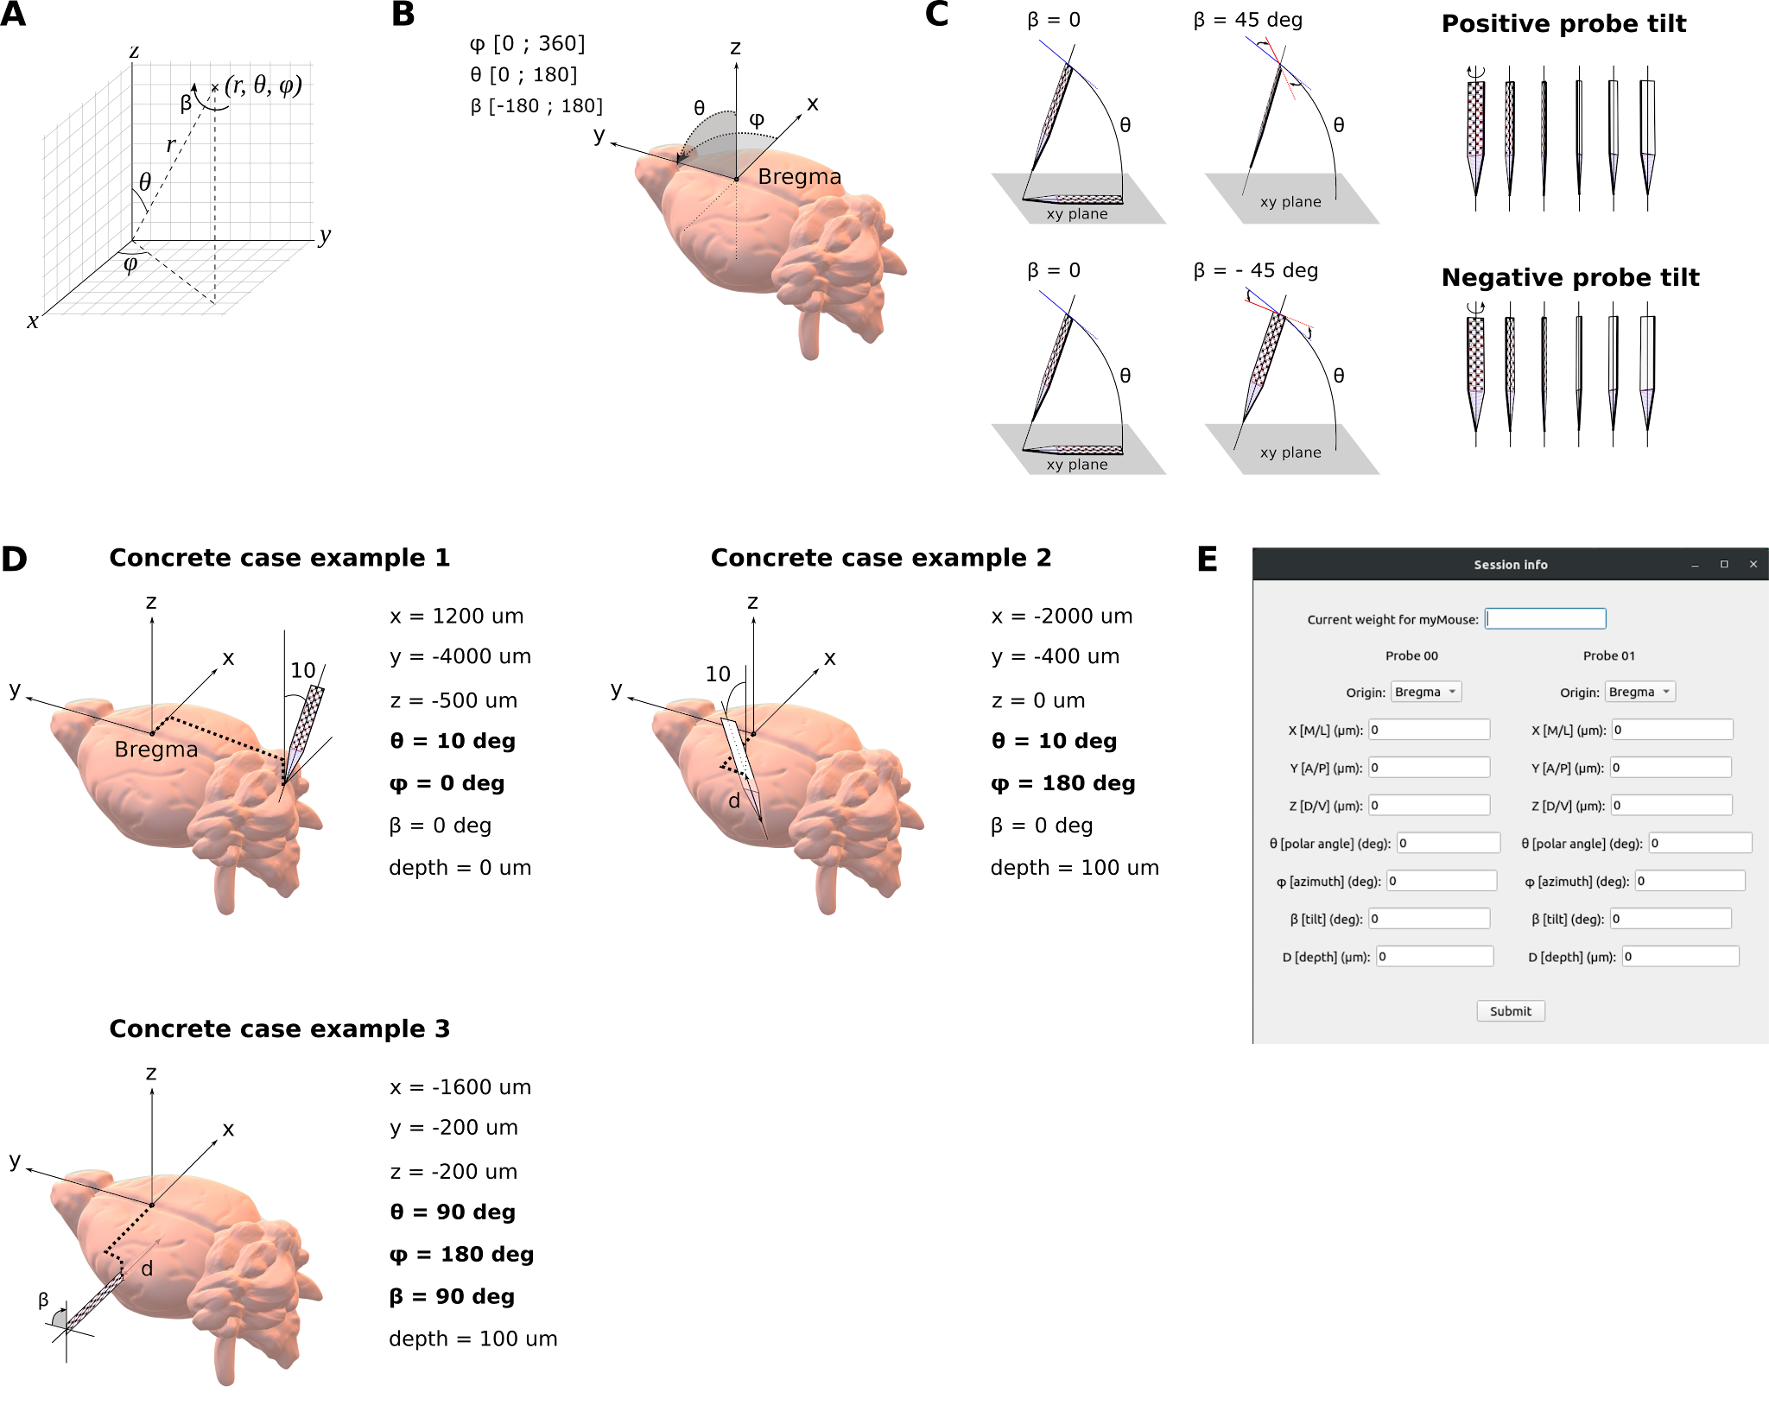
Bregma is defined as Voxel ML-566, AP-540, DV-33 within the 10um volume of the Allen CCF mouse Atlas¹⁵

Coordinate System: A) Standard polar angles are used, alongside the standard [x,y,z] base. In total, an electrode trajectory registers 7 entries (3 angles, 3 coordinates, depth) to define a probe insertion. B) The coordinate system is aligned to the ML (x, Right: positive), AP (y, A: positive), DV (z, D: positive) stereotaxic axis and zeroed at Bregma. The boundaries for each angle are indicated. The roll is the
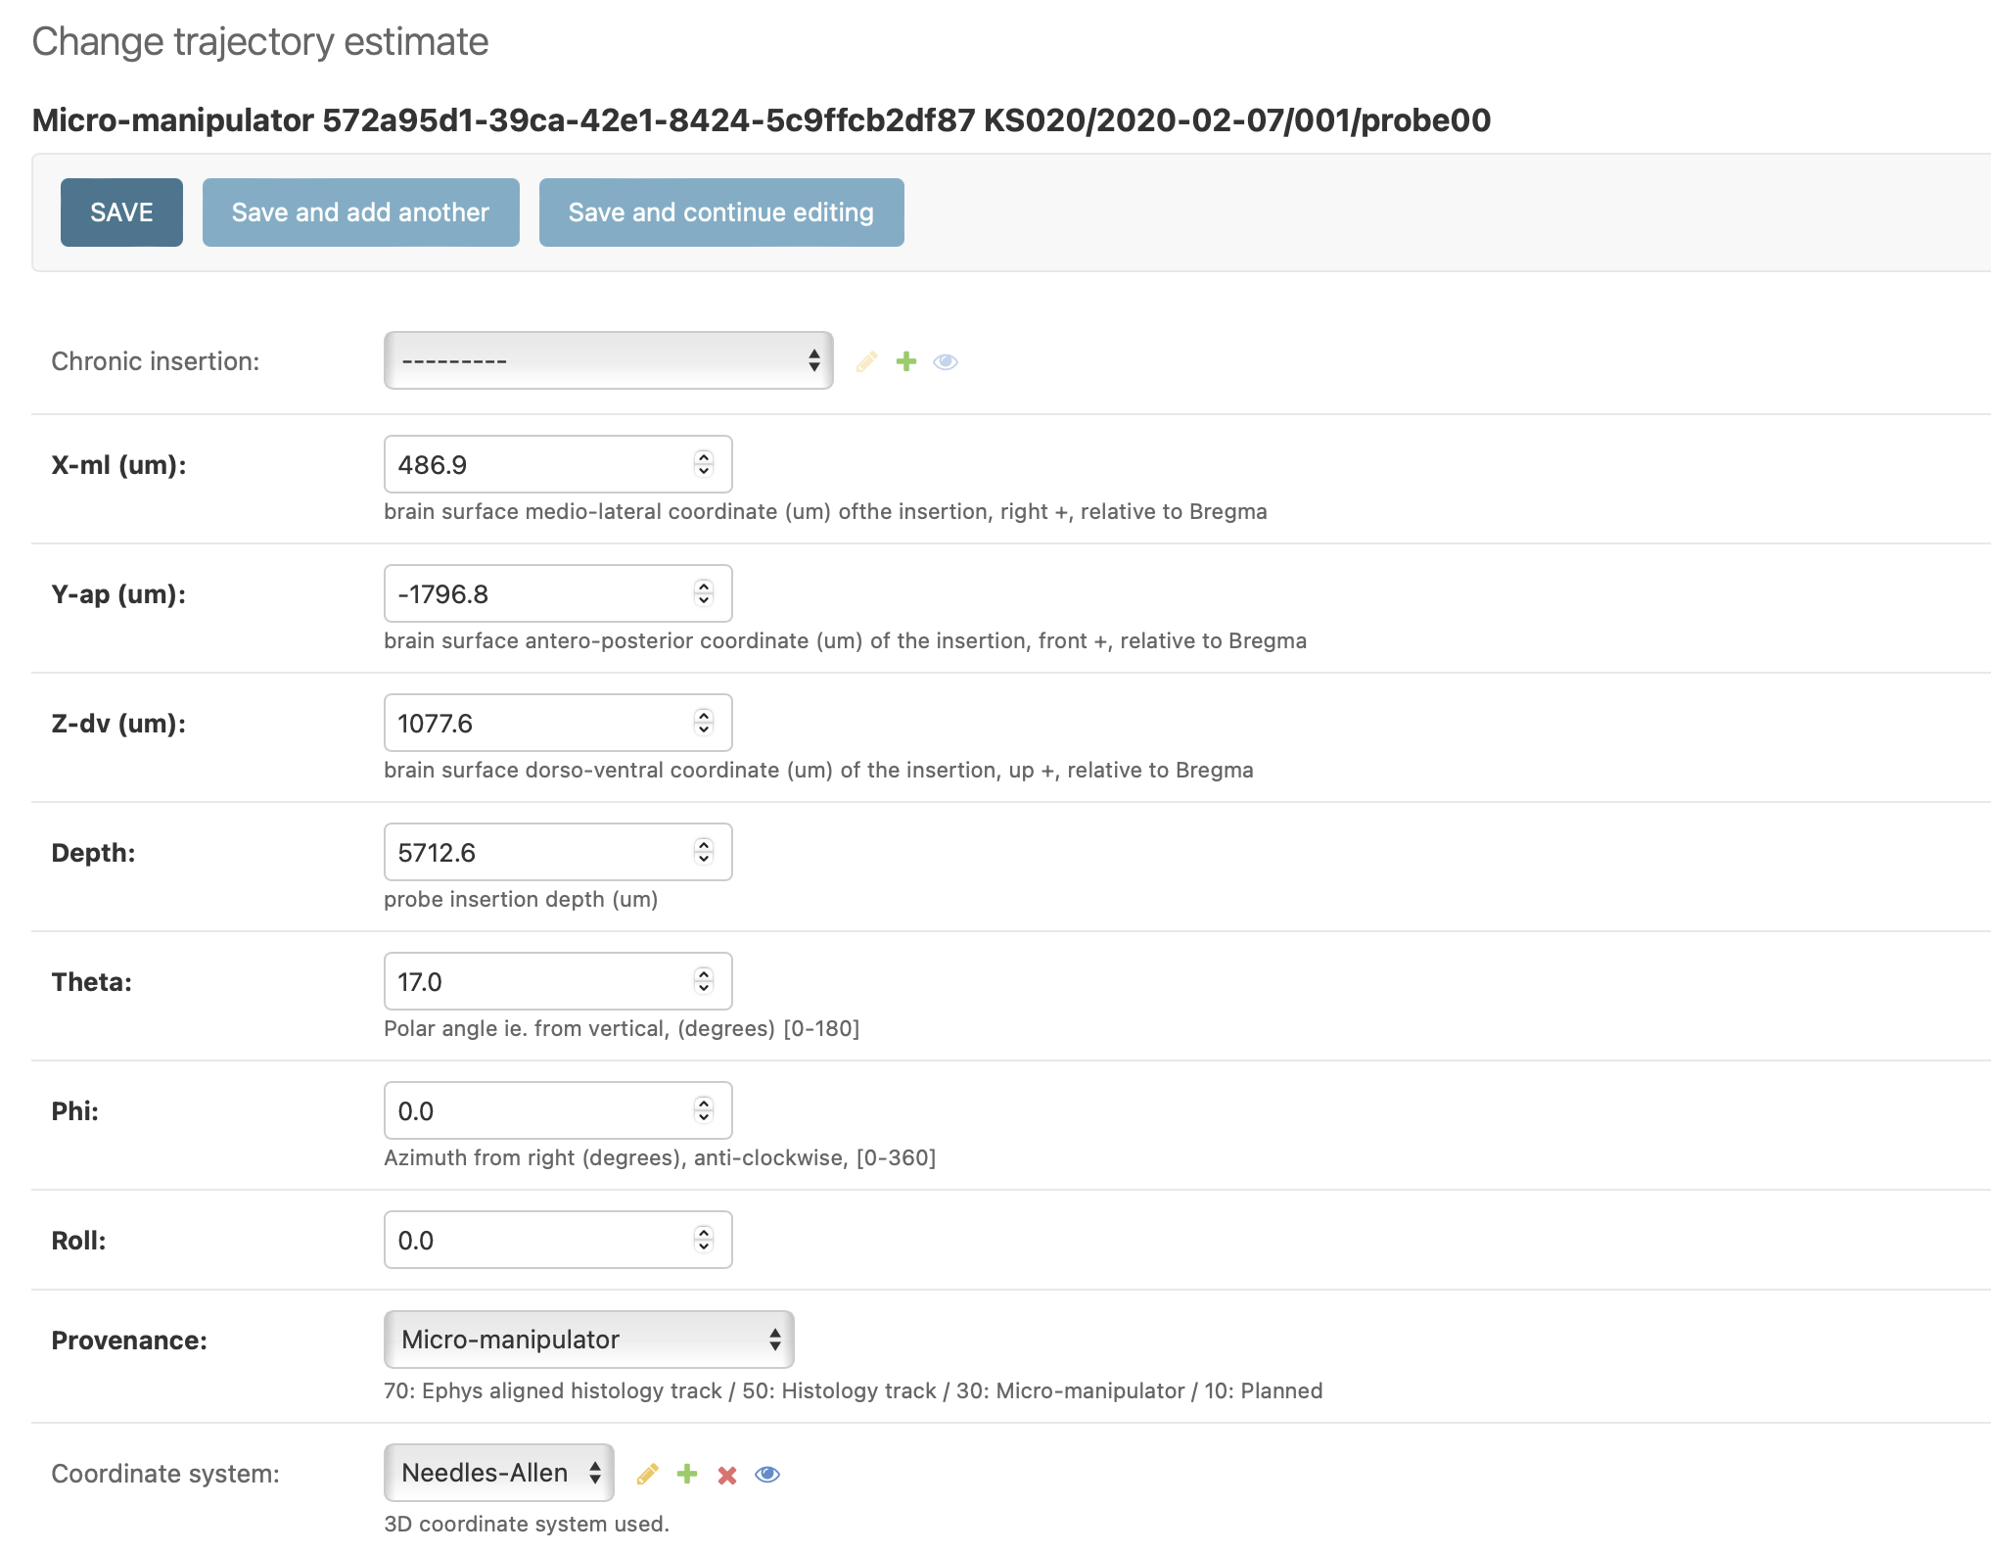

Computing response type using choice and stimulus side
Response type are: correct or incorrect.
3 variables are needed to compute it:
Variable | Type | Definition
_ibl_trials.choice | int64 | which choice was made in choiceworld: -1 (turn CCW), +1 (turn CW), or 0 (nogo)
_ibl_trials.contrastLeft | float64 | contrast of left-side stimulus (0...1) nan if trial is on other side
_ibl_trials.contrastRight | float64 | contrast of right-side stimulus (0...1) nan if trial is on other side
CCW : counter-clockwise
CW : clockwise
CW and CCW indicate how the mouse turns the wheel (from the perspective of the mouse).
Thus, if the stimulus appears on the right side of the screen, and the mouse turns the wheel CCW, the response type is correct.
Similarly, if the stimulus appears on the right side of the screen, and the mouse turns the wheel CW, the response type is false.
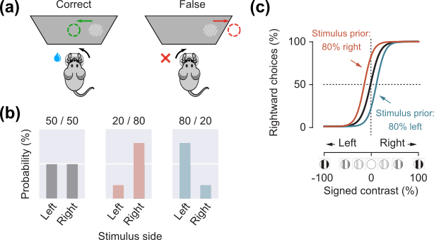

Example

Variable | Trials
choice | +1  (CW) | +1  (CW) | +1  (CW) | -1  (CCW) | -1 (CCW) | -1  (CCW) | 0  (nogo) | 0  (nogo)
contrastLeft | 0.5 | nan | nan | 1 | nan | nan | nan | 1
contrastRight | nan | 1 | 0 | nan | 0.5 | 0 | 0 | nan
feedbackType | +1 | -1 | -1 | -1 | +1 | +1 | -1 | -1

Aligning events to the onset of specific feedback type
The feedback variable contains all types of feedback received by the animal (e.g. noise sound, reward).
When wanting to align events (e.g. spikes) to the onset of one specific type of feedback, make sure to select only the corresponding feedback times.

Variable | Type | Definition
_ibl_trials.feedbackType | int64 | Whether feedback is positive or negative in choiceworld (-1 for negative feedback, +1 for positive feedback, no_go trials receive negative feedback)
_ibl_trials.feedback_times | float64 | Time of feedback delivery (reward or not) in choiceworld - in absolute seconds, rather than relative to trial onset

Example

Variable | Trials
_ibl_trials.feedbackType | +1 | 0 | +1 | -1 | 0 | +1
_ibl_trials.feedback_times | 2.1 | 3.5 | 4.1 | 6.0 | 8.4 | 9.5
REWARD | x |  | x |  |  | x

REWARD trial ID : [1, 3, 6]
REWARD times : [2.1, 4.1, 9.5]

Spikes
Collection: alf/probe00, alf/prob01, etc.

spikes.amps
Units: V
Type: double
Dimensions: [number of spikes]
Format: npy
Description: Amplitude of each spike (V)

spikes.clusters
Units: index
Type: int
Dimensions: [number of spikes]
Format: npy
Description: Cluster assignments for each spike (integers counting from 0). Can be used as direct indexing of the cluster.* attributes.

spikes.depths
Units: um
Type: double
Dimensions: [number of spikes]
Format: npy
Description: Depth along probe of each spike (µm; computed from waveform center of mass). 0 means probe tip, positive upwards.

spikes.samples
Units: seconds
Type: int
Dimensions: [number of spikes]
Format: npy
Description: Sample index of spikes in their own electrophysiology binary file.

spikes.times
Units: seconds
Type: float64
Dimensions: [number of spikes]
Format: npy
Description: Times of spikes (seconds, relative to experiment onset).

spikes.templates
Units: index
Type: int
Dimensions: [number of spikes]
Format: npy
Description: Detection template assignment for each spike (integers counting from 0). Can be used as direct indexing of the templates.* attributes.

Clusters
Collection: alf/probe00, alf/prob01, etc.

clusters.amps
Units: V
Type: double
Dimensions: [number of clusters]
Format: npy
Description: Average spike amplitude for the cluster (V)

clusters.depths
Units: µm
Type: double
Dimensions: [number of clusters]
Format: npy
Description: Depth along probe of each cluster (µm; computed from waveform center of mass). 0 means deepest site, positive means above this.

clusters.channels
Units: index
Type: int
Dimensions: [number of clusters]
Format: npy
Description: Channel assignments for each cluster (integers counting from 0). Refers to the channel that contains peak amplitude. Can be used as direct indexing of the channel.* attributes.

clusters.metrics
Units: N/A
Type: N/A
Dimensions: [number of clusters]
Format: csv
Description: Quality control metrics at the cluster level. Fields may vary but a basic subset includes: cluster_id, num_spikes, firing_rate, presence_ratio, presence_ratio_std, isi_viol, amplitude_cutoff, amplitude_std, ks2_label, ks2_contamination_pct.
Detailed description of each metric here: https://docs.google.com/document/d/1ba_krsfm4epiAd0zbQ8hdvDN908P9VZOpTxkkH3P_ZY/edit

clusters.probes
Units: index
Type: int
Dimensions: [number of clusters]
Format: npy
Description: Probe assignments for each cluster (integers counting from 0). Can be used as direct indexing of the probes.* attributes.

clusters.peakToTrough
Units: ms
Type: double
Dimensions: [number of clusters]
Format: npy
Description: Template waveform duration for the cluster. The duration is the time elapsed from peak to through (peak_sample - through_sample). Value can be negative if peak happens first (ms).

clusters.uuids
Units: int128
Type: UUIDv4
Dimensions: [number of clusters]
Format: csv
Description: Unique identifier assigned to each cluster when ALF files created and during manual curation.

clusters.waveforms
Units: V
Type: single
Dimensions: [number of clusters, number of time samples, number of selected channels]
Format: npy
Description: Waveform from spike sorting templates (stored as a sparse array, only for a subset of channels closest to the peak channel).

clusters.waveformsChannels
Units: Index
Type: int
Dimensions: [number of clusters, number of selected channels]
Format: npy
Description: Index of channels that are stored for each cluster waveform. Sorted by increasing distance from the maximum amplitude channel.

Waveforms
Collection: alf/probe00, alf/prob01, etc.

waveforms.templates
Units: uV
Type: single
Dimensions: [number of clusters, number of waveform channels, number of waveform samples]
Format: npy
Description: Median of up to 256 waveforms for each cluster. Usually the waveforms have 40 channels and 128 time samples.

waveforms.traces
Units: uV
Type: float16
Dimensions: [number of clusters, 256, 40, 128]
Format: npy
Description: Up to 256 waveforms from each cluster (NaNs if <256 available), with channel rephasing, bad channel interpolation, butterworth lowpass time filter, and spatial common average referencing applied.

waveforms.channels
Units: index
Type: int
Dimensions: [number of cluster * 256, 40]
Format: npz
Description: For each extracted waveform, the set of 40 channels around the peak trace which were extracted, based on a 200 micron radius.

clusters.metrics
Units: N/A
Type: N/A
Dimensions: [number of clusters * 256]
Format: pqt
Description: For each waveform, ordered by their assigned cluster, gives the sample index, peak channel, and assigned cluster. NaN rows if the cluster did not have 256 waveforms.

Drift Registration

drift.um
Units: um
Type: double
Dimensions: [ntimes, ndepths]
Format: npy
Description: "Result of the drift registration. 1D vector of drift estimation in um. A cell moving downwards relative to the probe will show as negative drift (ie. it overlays on the raster).
For non-rigid drift, 2D vector where the first dimension corresponds to the time of the estimation and the second dimension to the depth of the estimate (see the scale datasets)"

drift.times
Units: secs
Type: double
Dimensions: [ntime]
Format: npy
Description: Time of the probe corresponding to each of the drift matrix row.

drift_depths.um
Units: um
Type: double
Dimensions: [ntime]
Format: npy
Description: For non-rigid registration, depth corresponding to each of the drift matrix column.

Probes

probes.description
Units: N/A
Type: text
Dimensions: [number of probes]
Format: json
Description: JSON with one entry per probe containing label, model (3A, 3B1, 3B2),serial and raw_file_name.
import json
with open(probe_description_file) as fid:
probes_description = json.reads(fid.read())

Channels
Collection: alf/probe00, alf/prob01, etc.

channels.localCoordinates
Units: index
Type: float
Dimensions: [number of channels]
Format: npy
Description: relative to probe coordinate system (µm): x (first) dimension is on the width of the shank while (y) is the depth where 0 is the deepest site, and positive above this.

channels.probes
Units: index
Type: int
Dimensions: [number of channels]
Format: npy
Description: Probe assignments for each channel (integers counting from 0). Can be used as direct indexing for the probes.* attributes.

channels.rawInd
Units: index
Type: int
Dimensions: [number of channels]
Format: npy
Description: array of integers saying which index in the raw recording file (of its home probe) that the channel corresponds to (counting from zero). Can be used as direct indexing for the raw binary files (AP and LF).

channels.mlapdv
Units: µm
Type: double
Dimensions: [number of channels, 3]
Format: npy
Description: 3d location of the channels relative to bregma following ephys alignment - mediolateral; anterior-posterior; dorsoventral coordinates (um)

channels.brainLocationIds_ccf_2017
Units: Index
Type: int
Dimensions: [number of channels]
Format: npy
Description: Brain location id of channels following ephys alignment obtained from 25um resolution 2017 Allen Common Coordinate Framework

channels.labels
Units: N/A
Type: int
Dimensions: [number of channels]
Format: npy
Description: Bad channel detection outcome, 0 is good, 1 corresponds to dead or low amplitude channels, 2 corresponds to noisy channels, 3 corresponds to channels labeled as outside of the brain

Templates
Collection: alf/probe00, alf/prob01, etc.

template.amps
Units: V
Type: double
Dimensions: [number of templates]
Format: npy
Description: Average spike amplitude for the template (V)

templates.waveforms
Units: V
Type: single
Dimensions: [number of templates, number of time samples, number of selected channels]
Format: npy
Description: Waveform of automatic spike sorting templates (stored as a sparse array, only for a subset of channels closest to the peak channel)

templates.waveformsChannels
Units: Index
Type: int
Dimensions: [number of templates, number of selected channels]
Format: npy
Description: Index of channels that are stored for each template. Sorted by increasing distance from the maximum amplitude channel.

Sample waveforms

_phy_spikes_subset.waveforms
Units: V
Type: double
Dimensions: [number of spikes, number of time samples, number of selected channels]
Format: npy
Description: Sample waveform of spike traces extracted from raw data

_phy_spikes_subset.channels
Units: Index
Type: int
Dimensions: [number of spikes, number of selected channels]
Format: npy
Description: Index of channels that are stored for each sample spike waveform. Sorted by increasing distance from the maximum amplitude channel.

_phy_spikes_subset.spikes
Units: Index
Type: int
Dimensions: [number of spikes]
Format: npy
Description: Index of spikes

Raw Synchronization Data
The following datasets can be loaded and read by our automatic extraction pipeline.

_ibl_experiment.description
Units: N/A
Type: text
Dimensions: N/A
Format: yaml
Collection: N/A
Description: A list of acquisition devices and behaviour protocols, along with the data and sync file location. The root keys are (devices, sync, task, procedures). An annotated example can be found here.

_*_DAQdata.raw
Units: voltes, samples, seconds
Type: float64
Dimensions: [nSamples, nch]
Format: bin, tdms, mat, npy
Collection: raw_sync_data, raw_widefield_data, raw_photometry_data, etc.
Description: The output of the DAQ software for a given device. The namespace should identify the DAQ model or acquisition software, e.g. ‘mcc’, ‘ni’ or ‘timeline’. The file may contain timestamps and associated metadata, or this may be found in the below two optional datasets.

_*_DAQdata.timestamps
Units: seconds
Type: float64
Dimensions: nSamples
Format: npy
Collection: raw_sync_data, raw_widefield_data, raw_photometry_data, etc.
Description: The DAQ software timestamps for a given device. The namespace should identify the DAQ model or acquisition software, e.g. ‘mcc’, ‘ni’ or ‘timeline’.

_*_DAQdata.meta
Units: N/A
Type: string
Dimensions: N/A
Format: json
Collection: raw_sync_data, raw_widefield_data, raw_photometry_data, etc.
Description: Associated DAQ metadata, such as input and output channel configurations. The metadata structure varies between namespaces.

_*_DAQdata.wiring
Units: N/A
Type: text
Dimensions: [channels, device_name]
Format: json
Collection: raw_widefield_data, raw_photometry_data, etc.
Description: A map of the channel IDs and their corresponding device label, e.g. {ai1: bpod}. There are three root keys: ‘SYSTEM’, ‘SYNC_WIRING_DIGITAL’ and ‘SYNC_WIRING_ANALOG’. The corresponding ‘SYSTEM’ value is a label such as ‘Widefield’.

Raw Electrophysiology Data
Collection: raw_ephys_data

_iblqc_ephysSpectralDensity.power
Units: V**2/Hz
Type: float32
Dimensions: [nfreqs, nch]
Format: npy
Description: Power Spectral Density for all channels (V**2/Hz).

_iblqc_ephysSpectralDensity.freqs
Units: Hz
Type: float32
Dimensions: [nfreqs]
Format: npy
Description: Frequency scale for the spectrogram (Hz).

_iblqc_ephysTimeRms.rms
Units: V
Type: float32
Dimensions: [ntwin, nch]
Format: npy
Description: RMS amplitude as a function of time (V)

_iblqc_ephysTimeRms.timestamps
Units: s
Type: float32
Dimensions: [ntwin]
Format: npy
Description: Time scale for the RMS amplitude as a function of time, relative to the raw binary ephys file (s).

_iblqc_ephysChannels.apRMS
Units: V
Type: float32
Dimensions: [nchan]
Format: npy
Description: Median RMS per channel from samples of raw [nch, 0] and destriped [nch, 1] ephys data (V). (ap: computed for the AP band)

_iblqc_ephysChannels.labels
Units: N/A
Type: int
Dimensions: [nchan]
Format: npy
Description: Labels of automatic bad channel detections (int) 0: ok, 1: dead or low amplitude, 2: noisy, 3: out of the brain.

_iblqc_ephysChannels.rawSpikeRates
Units: Hz
Type: float32
Dimensions: [nchan]
Format: npy
Description: Raw spike rate per channel without clustering or collision handling - for early stages raw electrophysiology data QC purposes. [Hz]

_spikeglx_sync.channels
Units: index
Type: int
Dimensions: [nsync_pulses]
Format: npy
Description: 0 based index corresponding to the raw file sync channel used [0-15 on 3A, 0-8 on 3B].

_spikeglx_sync.polarities
Units: sign [-1, 1]
Type: float32
Dimensions: [nsync_pulses]
Format: npy
Description: Polarity of detected front: 1: rising, -1 falling

ephysData.raw.lf
Units: samples
Type: int16
Dimensions: [number of samples, number of channels]
Format: flat binary (*.bin), or mtscomp compressed (*.cbin, *.ch)
Description: Raw electrophysiology data. Low Field Potential.

# the following examples will read and convert to Volts
import spikeglx
lf_file = "/path/to/my/_spikeglx_ephysData_g0_t0.imec1.lf.cbin"
sr = spikeglx.Reader(lf_file)
sr[0:10000]
# this assumes you have 3 files on disk:
# _spikeglx_ephysData_g0_t0.imec1.lf.cbin
# _spikeglx_ephysData_g0_t0.imec1.lf.meta
# _spikeglx_ephysData_g0_t0.imec1.lf.ch

Note: The sampling frequency can be accessed via sr.fs (cf SpikGLX doc)

ephysData.raw.ap
Units: samples
Type: int16
Dimensions: [number of samples, number of channels]
Format: flat binary (*.bin), or mtscomp compressed (*.cbin, *.ch)
Description: Raw electrophysiology data. Action Potential.
# the following examples will read and convert to Volts
from ibllib.io import spikeglx
ap_file = "/path/to/my/_spikeglx_ephysData_g0_t0.imec1.ap.cbin"
sr = spikeglx.Reader(ap_file)
sr[0:10000]
# this assumes you have 3 files on disk:
# _spikeglx_ephysData_g0_t0.imec1.ap.cbin
# _spikeglx_ephysData_g0_t0.imec1.ap.meta
# _spikeglx_ephysData_g0_t0.imec1.ap.ch

ephysData.raw.nidq
Units: samples
Type: int16
Dimensions: [number of samples, number of channels]
Format: flat binary (*.bin), or mtscomp compressed (*.cbin, *.ch)
Description: Raw electrophysiology data from the breakout box. Contains synchronization pulses from behaviour devices for 3B Neuropixel.

ephysData.raw.meta

Format: text
Description: Raw electrophysiology data support file containing acquisition information.

from ibllib.io import spikeglx
metadata_file = "/path/to/my/_spikeglx_ephysData_g0_t0.imec1.lf.meta"
spikeglx.read_meta_data(metadata_file)

ephysData.raw.sync

Units: s
Type: float64
Dimensions: [number of sync samples, 2]
Format: npy
Description: Synchronization for binary file: 2 columns giving self-time in seconds and reference time in seconds

ephysData.raw.timestamps

Units: samples/seconds
Type: float64
Dimensions: [number of sync samples, 2]
Format: npy
Description: 2 columns file containing time synchronisation information for the AP binary file: sample index in the first column and session time in the second column. Note that sample indices may not be integers

ephysData.raw.wiring

Format: json
Description: Description of wirings of the synchronization traces. Examples for 3A and 3B.

Raw Behavior Data
Collection: raw_behavior_data, raw_task_data_XX

audioOnsetGoCue.times_mic
Units: seconds
Type: double
Dimensions: [number of go Cues detected]
Format: npy
Description: GoCue Times extracted from microphone data (s), in the time reference of the microphone. If the extraction algorithm managed to align to the behaviour timing, another `_iblmic_onsetGoCue.times` file will be present.

_iblmic_audioSpectrogram.frequencies
Units: Hz
Type: double
Dimensions: [1, number of frequencies]
Format: npy
Description: Frequency scale of audio spectrogram from microphone (Hz).

_iblmic_audioSpectrogram.power
Units: Hz
Type: double
Dimensions: [number of time windows, number of frequencies]
Format: npy
Description: Audio spectrogram from microphone, power.

_iblmic_audioSpectrogram.times_mic
Units: s
Type: double
Dimensions: [number of time windows]
Format: npy
Description: Time of the middle sample of the time window (s). Relative to the microphone samples time.

Trial Data
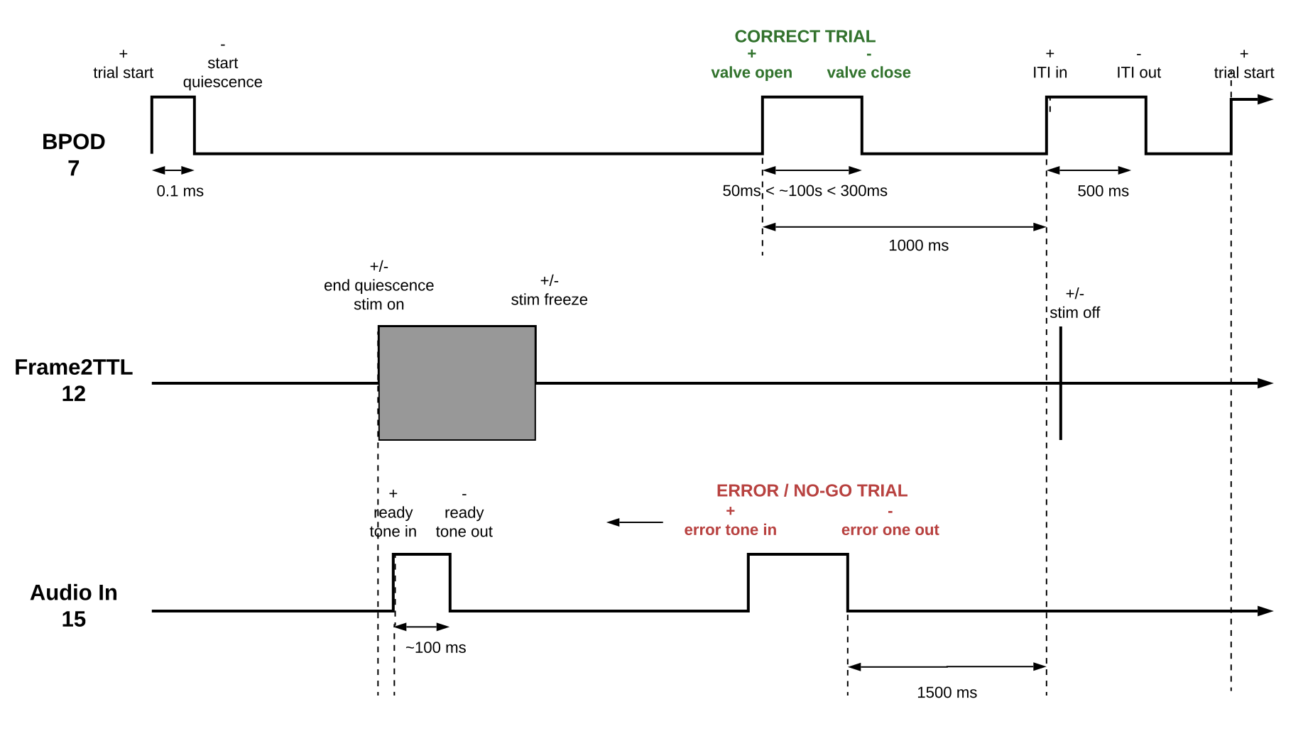
Note: All times are in absolute seconds from session start.
Between trials there is a period of closed-loop grey screen between stimOff and trial start where no stimuli are presented and wheel movement is ignored. This period is referred to as the inter-trial interval. After trial start (the first column of trials.intervals) the open-loop period of the trial begins where the wheel must be kept still.
Collection: alf

_ibl_trials.table
Units: various
Type: various
Dimensions: [number of trials, n]
Format: pqt
Description: A table of trial events, one per trial. Events include: intervals, goCue_times, response_times, choice, stimOn_times, contrastLeft, contrastRight, feedbaack_times, feedbackType, rewardVolume, probabilityLeft, firstMovement_times
Table column descriptions:

intervals
Units: seconds
Type: double
Dimensions: [number of trials, 2]
Description: 2 column array giving each trial’s start (i.e. beginning of quiescent period) and end (i.e. stimulus off + 500ms*) times of trials in universal seconds. As a DataFrame, this will be split into 2 columns, intervals_0 and intervals_1.
*Note that the minimum ITI is 500ms, however due to implementation there is also a significant variable delay between intervals (typically an ITI is around a second). Therefore the true ITI can be found by taking intervals[n+1, 0] - stimOff_times[n].

goCue_times
Units: seconds
Type: double
Dimensions: [number of trials]
Description: The start time of the go cue tone. This is the time the sound is actually played, that is, the command sent through soundcard sync was fed back into Bpod. The go cue tone is a 100ms 5 kHz sine wave and occurs approximately at the time of stimulus onset.

response_times
Units: seconds
Type: double
Dimensions: [number of trials]
Description: The time at which a response was recorded. This marks the end of the closed loop state in Bpod and occurs when either 60 seconds have elapsed since the go cue, or the rotary encoder reaches a position equivalent to the stimulus on the screen reaching + or - 35º azimuth.
In practice it corresponds to the end of the ‘closed loop’ bpod task in the IBL task.

choice
Units: sign [-1, 0, 1]
Type: int64
Dimensions: [number of trials]
Description: The response type registered for each trial where -1 corresponds to turning the wheel CCW, +1 turning CW, and 0 being a timeout (‘no-go’) where the wheel wasn’t moved to threshold within the 60 second time window. See Computing response type using choice and stimulus side.

stimOn_times
Units: seconds
Type: double
Dimensions: [number of trials]
Description: The time at which the visual stimulus appears on the screen, as detected by the photodiode which is placed over the sync square that flips colour each time the screen is redrawn.

contrastLeft
Units: normalized
Type: double
Dimensions: [number of trials]
Description: The contrast of the stimulus that appears on the left side of the screen (-35º azimuth). When there is a non-zero contrast on the right, contrastLeft == 0, when there is no contrast on either side (a ‘catch’ trial), contrastLeft == NaN.

contrastRight
Units: normalized
Type: double
Dimensions: [number of trials]
Description: The contrast of the stimulus that appears on the right side of the screen (35º azimuth). When there is a non-zero contrast on the left, contrastRight == 0, when there is no contrast on either side (a ‘catch’ trial), contrastRight == NaN.

feedback_times
Units: seconds
Type: double
Dimensions: [number of trials]
Description: The time of feedback delivery. For correct trials this is the time of the valve TTL trigger command, for incorrect trials this is the time of the white noise output trigger.

feedbackType
Units: sign [-1, 1]
Type: int64
Dimensions: [number of trials]
Description: Whether the feedback was positive (+1) or negative (-1). Positive feedback indicates a correct response rewarded with sugar water. Negative feedback indicates a trial timeout or incorrect response followed by a white noise burst.

rewardVolume
Units: µl
Type: double
Dimensions: [number of trials]
Description: The volume of reward delivered on each trial. On trials where feedbackType == -1, rewardVolume == 0. The reward volume is typically within the range of 1.5 to 3 and should not change within a session.

probabilityLeft
Units: normalized
Type: double
Dimensions: [number of trials]
Description: Probability that the stimulus will be on the left-hand side for the current trial. The probability of right is 1 minus this. For repeat trials (trainingChoiceWorld) the probability is N(bias,4), where bias is calculated using responses from the last 10 trials. During biased blocks (biasedChoiceWorld) the probability may be 0.5, 0.8, or 0.2.

firstMovement_times
Units: seconds
Type: double
Dimensions: [number of trials]
Description: The time of the first detected movement of the trial with a sufficiently large amplitude. To be counted, the movement must occur within the open-loop period, which starts just before the go cue* and ends at feedback time. A NaN value indicates that no movement was detected for that trial.
*The first movement onset is sometimes just before the cue, occurring in the gap between quiescence end and cue start, or during the quiescence period but sub-threshold. The movement is sufficiently large if it is greater than or equal to .1 radians. [Code]

_ibl_trials.stimOff_times
Units: seconds
Type: float
Dimensions: [number of trials]
Format: npy
Description: Time in seconds, relative to the session start, of the stimulus offset, as recorded by an external photodiode.

_ibl_trials.quiescencePeriod
Units: seconds
Type: float
Dimensions: [number of trials]
Format: npy
Description: The pre-stimulus quiescence period in seconds. The exact time for each trial is drawn from a truncated exponential, range 0.2-0.5 seconds.

_ibl_subjectTrials.table
Collection: aggregates/Subjects/{lab}/{Subject}/
Units: various
Type: various
Dimensions: [number of all trials, n]
Format: pqt
Description: Aggregate of all trials of one subject, aggregated from all sessions that have complete trials data. One row per trial, columns represent trial events and include all columns of _ibl_trials.table (intervals, goCue_times, response_times, choice, stimOn_times, contrastLeft, contrastRight, feedback_times, feedbackType, rewardVolume, probabilityLeft, firstMovement_times) plus information about the session the trial stems from ('session', 'session_start_time', 'task_protocol', 'protocol_number'), plus extra trials columns ('goCueTrigger_times', 'stimOnTrigger_times', 'stimFreezeTrigger_times', 'stimFreeze_times', 'stimOffTrigger_times', 'stimOff_times', 'phase', 'position', 'quiescence').

_ibl_subjectTraining.table
Collection: aggregates/Subjects/{lab}/{Subject}/
Units: various
Type: various
Dimensions: [number of training criteria reached, 2]
Format: pqt
Description: Overview of training status for subject, each row contains the date and session at which the subject reached different training criterion. Index is date, columns are training_status and session .
Possible status
['habituation', 'in training', 'trained 1a', 'trained 1b', 'ready4ephysrig',, 'ready4delay', 'ready4recording', ‘untrainable’, ‘unbiasable’, 'not_computed']

Trial Data (optogenetics)
Collection: alf

_ibl_trials.laserStimulation
Units: seconds
Type: float
Dimensions: [number of trials]
Format: npy
Description: Whether or not the laser was actuating during the trial (outcome): 0:no laser, 1: laser, np.nan: no info.

_ibl_trials.laserProbability
Units: normalized
Type: float
Dimensions: [number of trials]
Format: npy
Description: Probability of the laser being actuating (prior).

_ibl_trials.laserIntervals
Units: seconds
Type: float
Dimensions: [number of trials, 2]
Format: npy
Description: Time in seconds, relative to the session start, of the onset and offset of the laser stimulation.

Optogenetic Data
Collection: alf

_ibl_laserStimulation.intervals
Units: seconds
Type: float
Dimensions: [number of events, 2]
Format: npy
Description: Time in seconds, relative to the session start, of the onset and offset of the laser stimulation.

chWheel Data
For information on working with wheel data, including calculating velocity and converting units, see this guide.
Collection: alf

_ibl_wheel.position
Units: radians
Type: double
Dimensions: [number of wheel ticks]
Format: npy
Description: Absolute unwrapped angle of the wheel from session start. The sign from the subject perspective corresponds to mathematical convention: counter clockwise is positive.

_ibl_wheel.timestamps
Units: seconds
Type: double
Dimensions: [number of wheel ticks]
Format: npy
Description: Time in seconds of the corresponding wheel event, relative to session start. Note that the wheel delivers a sample only when crossing a tick, which makes this time-serie very irregular.

_ibl_wheelMoves.intervals
Units: seconds
Type: double
Dimensions: [number of movements, 2]
Format: npy
Description: The onset and offset times of all detected movements. Movements are defined as a wheel movement of at least 0.012 rad over 200ms. For a rotary encoder of resolution 1024 in X4 encoding, this is equivalent to around 8 ticks. Movements below 50ms are discarded and two detected movements within 100ms of one another are considered as a single movement. For the onsets a lower threshold is used to find a more precise onset time.

_ibl_wheelMoves.peakAmplitude
Units: radians
Type: double
Dimensions: [number of movements]
Format: npy
Description: The absolute maximum amplitude of each detected wheel movement, relative to onset position.
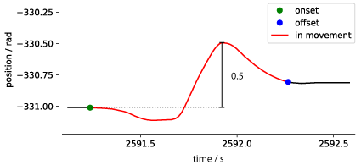

Camera Data

camera.times
Units: seconds
Type: double
Dimensions: [number of frames]
Format: npy
Collection: alf
Description: Time in seconds of the corresponding frame, relative to session start. These are the times of the camera TTL pulse during every frame capture. There are three ALFs associated with this dataset: _ibl_leftCamera.times, _ibl_rightCamera.times and _ibl_bodyCamera.times.

camera.raw
Units: frames
Type: double
Dimensions: [1280 (640), 1024 (512), number of frames]
Format: mp4 (h.264)
Collection: raw_video_data
Description: The compressed video from the cameras. There are three ALFs associated with this dataset: _iblrig_leftCamera.raw, _iblrig_rightCamera.raw, and _iblrig_bodyCamera.raw. The right side cameras will run at 150 Hz (spatial resolution 640 x 512) and the left side camera at 60 Hz (spatial resolution 1280 x 1024), the body camera at 30 Hz (spatial resolution 640 x 512)

_iblrig_*Camera.frame_counter
Units: number
Type: float64
Dimensions: [number of frames]
Format: bin
Collection: raw_video_data
Description: The frame counter from the camera hardware starts at arbitrary value. Saved as floating point 64 bits

_iblrig_*Camera.GPIO
Units: number
Type: float64
Dimensions: [number of frames]
Format: bin
Collection: raw_video_data
Description: The GPIO pin state from the camera hardware, saved as floating point 64 bits.

_iblrig_*Camera.frameData
Units: [
- UTC ticks from BehaviorPC,
- CameraTimestamps (Needs unclycling and conversion),
- Frame counter,
- GPIO pin state integer representation of 4 pins
]
Type: float64
Dimensions: [number of frames x 4]
Format: bin
Collection: raw_video_data
Description: Binary file of nframes X 4 columns storing the raw representation of:
Timestamp → UTC ticks from BehaviorPC (100's of ns since midnight 1/1/0001) embeddedTimeStamp → Camera timestamp (Needs unclycling and conversion) embeddedFrameCounter → Frame counter embeddedGPIOPinState → GPIO pin state integer representation of 4 pins

camera.dlc
Units: number
Type: float32
Dimensions: [number of frames, number of tracked points x 3]
Format: pqt
Collection: alf
Description: Coordinates of points tracked in the videos using DeepLabCut (DLC). Can be read with pandas.read_parquet. For each tracked point, the data frame contains a row each for the x coordinate, y coordinate, and likelihood over time. There are three ALF files associated with this dataset type: _ibl_leftCamera.dlc.pqt, _ibl_rightCamera.dlc.pqt, and _ibl_bodyCamera.dlc.pqt The number of tracked points is 11 for the left and right camera and 1 for the body camera.

camera.ROIMotionEnergy
Units: number
Type: float32
Dimensions: [number of frames]
Format: npy
Collection: alf
Description: The motion energy between the current frame and the subsequent frame, calculated within a ROI (see ROIMotionEnergy.position). There are three ALF files associated with this dataset type: leftCamera.ROIMotionEnergy.npy, rightCamera.ROIMotionEnergy.npy, and bodyCamera.ROIMotionEnergy.npy

ROIMotionEnergy.position
Units: number
Type: int64
Dimensions: [4,]
Format: npy
Collection: alf
Description: The coordinates of the region of interest (ROI) in which the camera.ROIMotionEnergy is calculated. The entries of this array are (w, h, x, y) where w and h are the width and height of the ROI in pixels, and x and y are the coordinates of the upper left corner pixel of the ROI. There are three ALF files associated with this dataset type: leftROIMotionEnergy.position.npy, rightROIMotionEnergy.position.npy, and bodyROIMotionEnergy.position.npy
CAUTION: As each software will load the video in a different orientation, the ROI might need to be adapted. For example, when loading the video with cv2 in Python, x and y axes are flipped from the convention used above. The ROI then is this box: [y:y+h, x:x+w]

camera.features
Units: number
Type: float32
Dimensions: [number of frames, number of features]
Format: pqt
Collection: alf
Description: Features computed from the dlc trace of each camera. Currently, this contains the raw and smoothed pupil Diameter (‘pupilDiameter_raw’ and ‘pupilDiameter_smooth’). As these are only available for left and right camera, there are currently two ALF files associated with this dataset type: _ibl_leftCamera.features.pqt and _ibl_rightCamera.features.pqt (but _ibl_bodyCamera.features.pqt might be added in the future).

licks.times
Units: number
Type: float32
Dimensions: [number of licks,]
Format: npy
Collection: alf
Description: Time stamps of licks as detected from tongue dlc traces. If left and right camera exist, the licks detected from both cameras are combined.

camera.lightningPose
Units: number
Type: float32
Dimensions: [number of frames, number of tracked points x 3]
Format: pqt
Collection: alf
Description: Coordinates of points tracked in the videos using LightningPose (LP). Can be read with pandas.read_parquet. For each tracked point, the data frame contains a row each for the x coordinate, y coordinate, and likelihood over time. There are three ALF files associated with this dataset type: _ibl_leftCamera.lightningPose.pqt, _ibl_rightCamera.lightningPose.pqt, and _ibl_bodyCamera.lightningPose.pqt The number of tracked points is 11 for the left and right camera and 1 for the body camera.

Passive Data
NB: All times are in absolute seconds from session start.
Passive protocol runs after ephys protocol description here.

_ibl_passivePeriods.intervalsTable*.csv
Units: seconds
Type: float64
Dimensions: [2, 4]
lines = ['start', 'stop']
columns = ['passiveProtocol', 'spontaneousActivity', 'RFM', 'taskReplay'],
Format: csv
Description: Table of times of different passiveCW periods.

_ibl_passiveRFM.times*.npy
Units: seconds
Type: float64
Dimensions: [nFrames]
Format: npy
Description: Interpolated times for all frame presentations in Receptive Field Mapping period.

_ibl_passiveGabor.table*.csv
Units: [seconds, seconds, visual degrees, [0, 1], [0, 2*Pi]
Type: float64
Dimensions: [nPresentations, 5]
lines = nPresentations = 180
columns = [start, stop, position, contrast, phase]
Format: csv
Description: Gabor patch presentations table of details of visual stimulus per presentation. Presentations with negative visual degrees appeared in the left visual hemifield; positive visual degrees, in the right.

_ibl_passiveStims.table*.csv
Units: seconds
Type: float64
Dimensions: [nRepeats, 6]
lines = nRepeats = 40
columns = [valveOn, valveOff, toneOn, toneOff, noiseOn, noiseOff]
Format: csv
Description: Onset and offset times of all other stimuli presented during the passiveCW protocol.

_iblrig_RFMapStim.raw*.bin
Units: color
Type: uint8
Dimensions: [nframes, nx, ny]
Where nx == ny == 15
Format: bin
Description: Raw receptive field mapping stimulus matrix.

Imaging Data (multi-photon calcium imaging)
Collection: alf/FOV_XX

mpci.times
Units: seconds
Type: float64
Dimensions: [nframes]
Format: npy
Description: The time of each frame. Note that there may be further offsets available for each scanline or pixel/voxel in the mpciStack.timeshift.npy dataset.

mpci.badFrames
Units: N/A
Type: boolean
Dimensions: [nframes]
Format: npy
Description: Bad frames as identified by processing software. Typically these are frames where the image registration was considered poor.

mpci.mpciFrameQC
Units: N/A
Type: uint8
Dimensions: [nframes]
Format: npy
Description: An enumeration of frame-level quality control as added by experimenter. 0 means good, other values defined in mpciFrameQC.names.tsv

mpciFrameQC.names
Units: N/A
Type: str
Dimensions: [nQCtypes, 2]
Format: tsv
Description: Human-readable definition of QC types. First column, 'qc_values', contains unsigned ints where 0 always should mean good. Second column, 'qc_labels', contains a short human-readable description.

mpci.ROIActivityF
Units: photodetector output units
Type: float32
Dimensions: [nFrames, nROIs]
Format: npy
Description: Mean activity of all pixels in each ROI.

mpci.ROINeuropilActivityF
Units: photodetector output units
Type: float32
Dimensions: [nFrames, nROIs]
Format: npy
Description: Mean activity neuropil pixels neighboring each ROI.

mpci.ROIActivityDeconvolved
Units: AU
Type: float32
Dimensions: [nFrames, nROIs]
Format: npy
Description: Neuropil-subtracted deconvolved activity of each ROI using standard parameters, which can be recovered from _suite2p_ROIData.raw.

mpciROIs.mpciROITypes
Units: N/A
Type: int16
Dimensions: [nROIs]
Format: npy
Description: Numerical enumeration of ROI type for each ROI.

mpciROITypes.names
Units: N/A
Type: str
Dimensions: [nROItypes, 2]
Format: tsv
Description: Human-readable definition of ROI types (neuron, dendrite, etc). First column, 'roi_values', contains the ROI type enumeration. The second, 'roi_labels', contains a string description.

mpciROIs.cellClassifier
Units: N/A
Type: float64
Dimensions: [nROIs]
Format: npy
Description: Floating-point cell classifier score for each ROI, ranging between 0 and 1.

mpciROIs.masks
Units: AU
Type: float
Dimensions: [nROIs, H, W]
Format: sparse_npy
Description: Floating-point mask of each ROI, in 2D or 3D according to how you did detection. Saved as a sparse array. sum(roi_mask * frames[ypix,xpix,:]) = fluorescence

mpciROIs.neuropilMasks
Units: AU
Type: boolean
Dimensions: [nROIs, H, W]
Format: sparse_npy
Description: Boolean neuropil mask for each ROI, in 2D or 3D according to how you did detection. Saved as a sparse array.

mpciROIs.mlapdv
Units: um
Type: float64
Dimensions: [nROIs, 3]
Format: npy
Description: 3D location of the ROI centroid relative to bregma - mediolateral; anterior-posterior; dorsoventral coordinates (um). '_estimate' means not resolved with histology.

mpciROIs.brainLocationIds
Units: ID
Type: int32
Dimensions: [nROIs]
Format: npy
Description: Brain location acronym of each ROI centroid. A '_ccf_2017' in the dataset means an alignment obtained from 25um resolution 2017 Allen Common Coordinate Framework. '_estimate' means not resolved with histology.

mpciROIs.stackPos
Units: pixels
Type: int64
Dimensions: [nROIs, 3]
Format: npy
Description: Y, X, and Z (plane) pixel coordinates of each ROI's centroid.

mpciROIs.uuids
Units: int128
Type: UUIDv4
Dimensions: [nROIs]
Format: csv
Description: Unique identifier assigned to each ROI when ALF files created after ROI detection.

_suite2p_ROIData.raw
Format: zip of npy
Description: Raw cell detection output ROI data.

Raw Neuroimaging Data
Collection: raw_imaging_data_XX, raw_widefield_data

imaging.frames
Units: pixels
Type: uint8
Dimensions: [nframes, nx, ny(, nchannels)]
Format: bin, dat, tar.bz2, tif, mov
Description: Raw frame images with the dimensions [nframes, nx, ny(, nchannels)]. Note that depending on modality, multiple planes and channels may be stitched together and/or presented in a different order.

_ibl_rawImagingData.meta
Units: N/A
Type: string
Format: json
Description: Image meta-data listing the depths and dimensions of each field of view, acquisition parameters, channels, and the MLAP coordinates of the imaging window center.

referenceImage.raw
Collection: raw_imaging_data_XX/reference
Units: pixels
Type: uint8
Dimensions: [nframes, nx, ny(, nchannels)]
Format: tif
Description: A fullfield multiphoton imaging picture for use in histology alignment.

referenceImage.stack
Collection: raw_imaging_data_XX/reference
Units: pixels
Type: uint8
Dimensions: [nframes, nx, ny(, nchannels)]
Format: tif
Description: A stitched mean multiphoton imaging stack, containing X and Y resolution/size information in the tiff header. Used in histology alignment.

referenceImage.meta
Collection: raw_imaging_data_XX/reference
Units: N/A
Type: string
Format: json
Description: Stack image meta-data listing the depth in microns of each slice in the stack, and ML and AP coordinates of the center.

Imaging Data (widefield, photometry, etc.)

imaging.times
Units: seconds
Type: float64
Dimensions: [nframes,]
Format: npy
Collection: alf/widefield, etc.
Description: The times of frame acquisition.

imaging.imagingLightSource
Units: index
Type: int32
Dimensions: [nframes,]
Format: npy
Description: Integer representing which channel was acquired for each frame. 0 channel indicates no light.

imagingLightSource.properties
Units: nm
Type: int32
Dimensions: [nLightSources,]
Format: htsv
Description: A map of channel number, colour and wavelength. NB: This is the light source wavelength, not the photosensor channel / emitted wavelength.

Widefield Data

widefieldEvents.raw
Units: N/A
Type: float
Dimensions: [nFrames, n]
Format: camlog
Collection: raw_widefield_data
Description: The output of the Camlog software used to collect widefield images. Contains frame times and LED number for each frame.

widefieldU.mask
Units: binary
Type: int32
Dimensions: [nH, nW]
Format: npy
Collection: raw_widefield_data
Description: User selected mask to restrict pixels in imaging.frames before applying preprocessing

widefieldChannels.wiring
Units: N/A
Type: text
Dimensions: [nLED, 2]
Format: json
Description: A map of LED wiring number to wavelength. Wiring number matches those in XXX column of widefieldEvents.raw.camlog

widefieldU.images
Units: pixels
Type: float
Dimensions: [nW, nH, nComponents]
Format: npy
Collection: alf/widefield
Description: Projected SVD spatial components (denoised/decomposed) where nW and nH are the dimensions of a single frame.

widefieldSVT.uncorrected
Units: pixels
Type: float
Dimensions: [nComponents, nFrames]
Format: npy
Collection: alf/widefield
Description: SVD temporal components (denoised/decomposed) of data.

widefieldSVT.haemoCorrected
Units: pixels
Type: float
Dimensions: [nComponents, nFrames / 2]
Format: npy
Collection: alf/widefield
Description: Haemodynamic corrected SVD temporal components of data.

widefieldChannels.frameAverage
Units: pixels
Type: float
Dimensions: [nLED, nW, nH]
Format: npy
Collection: alf/widefield
Description: Average image across each frame for each LED channel used in imaging.

widefieldLandmarks.dorsalCortex
Units: N/A
Type: text
Dimensions: N/A
Format: json
Collection: alf/widefield
Description: User selected landmarks and transform for widefield imaging to allow images to be transformed and aligned to Allen Atlas

subjectWidefieldU.mask_atlasTransformed
Units: binary
Type: int32
Dimensions: [nW, nH]
Format: npy
Collection: aggregates/Subjects/{lab}/{Subject}/
Description: User selected mask to apply to processed atlas transformed widefeild images. One mask per subject.

Photometry Data

_neurophotometrics_fpData.raw
Units: various
Type: various
Dimensions: [nFrames, n]
Format: pqt
Collection: raw_photometry_data
Description: Raw photometry data dataframe containing fluorescence data for every active channel (max: isosbestic, red and green) as well as information of coactive components with each frame (E.g TTL syncing pulse). This dataframe is a straight conversion of the neurophotometrics CSV file output by Bonsai to parquet, and versions change according to the bonsai workflow version used.

photometry.signal
Units: various
Type: various
Dimensions: [nFrames, n]
Format: pqt
Collection: alf/photometry
Description: A table containing photometry data for all photometry ROIS in a single session, one row per imaging frame. Columns include Region0G, Region1G … , the raw data from the individual regions. Times, the time of each frame. Wavelength and name, which describe the LED used to collect each frame. Include, a mask indicating which frames should be used in analysis.

photometryROI.locations
Units: various
Type: various
Dimensions: [nROI, n]
Format: pqt
Collection: alf/photometry
Description: Look up table from photometry ROI, to fiber name registered in the database and Allen brain location

